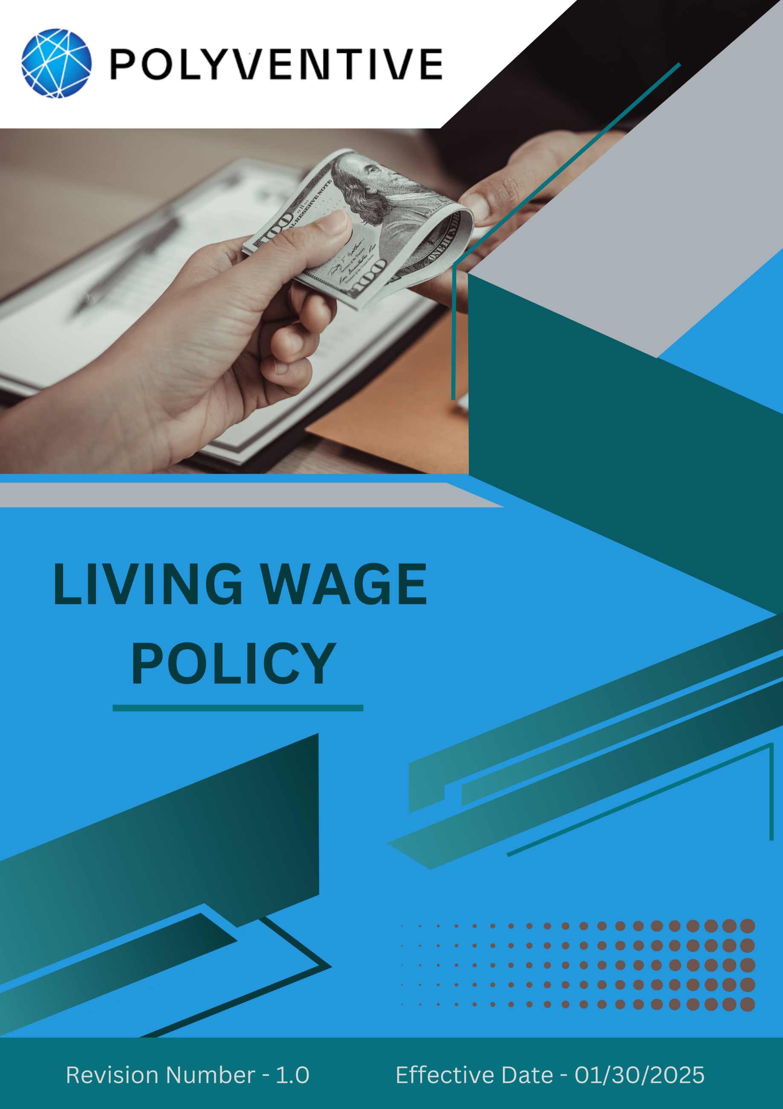
Index

❖ Introduction: 3
❖ Scope: 3
❖ Living Wage Commitment: 3
❖ Quantitative Targets: 4
❖ Action Framework: 5
❖ Roles and Responsibilities: 5
❖ Monitoring and Reporting: 6
❖ Communication and Transparency: 6
❖ Continuous Improvement: 7
❖ SDGs (Sustainable Development Goals) Covered in the Living Wage Policy 7
❖ Review: 8
❖ Employee Acknowledgement – Polyventive LLC Group Living Wage Policy 9

Introduction:
At POLYVENTIVE LLC (GROUP), we are committed to ensuring fair and equitable wages for all employees across our operations. We recognize that every individual deserves compensation that meets basic needs and supports a dignified standard of living. This Living Wage Policy reflects our dedication to employee well-being, responsible business practices, and alignment with international labor and human rights standards. By upholding these values, Polyventive strengthens its workforce and contributes to sustainable growth in the communities where we operate.

Scope:
This policy applies to all POLYVENTIVE LLC (GROUP) employees, workers, contractors, sub-contractors, suppliers, partners, and stakeholders across all operational locations. It covers our manufacturing sites, offices, and all associated business operations, and extends to interactions with clients, vendors, regulators, and the wider community.

Sr. No. | Address
1 | 140 Executive Dr SE, Calhoun, GA 30701
2 | 130 Executive Dr SE, Calhoun, GA 30701
3 | 1601 US-41, Calhoun, GA 30701
4 | Burlington Rd NE, Rome, GA 30161
5 | 1202 Dozier St., Dalton, GA 30721
6 | 1001 Boul Industrial St-Eustache, QC, J7R 6C3 Canada
7 | 6060 Rickenbacker Rd., Commerce, CA 90040

Living Wage Commitment:
Polyventive LLC is dedicated to ensuring that all employees and contract workers are compensated with a living wage, defined as the minimum income necessary for workers to meet their basic needs—such as food, housing, healthcare, and education while maintaining a dignified quality of life. Our living wage commitment includes:
- Wage Standards Above the Legal Minimum: Polyventive is committed to paying wages that exceed the legal minimum wage in the regions where we operate. We ensure that wages are sufficient to cover essential living expenses, promoting financial independence, stability, and overall well-being.
- Basic Needs Coverage: A living wage at Polyventive ensures that employees and contract workers can meet their fundamental needs, including food, housing, transportation, education, healthcare, and the ability to save. We assess local living conditions and set wages that accurately reflect the true cost of living in each region.
- Equal Pay for Equal Work: Polyventive is committed to maintaining pay equity across the organization, ensuring that no employee faces wage discrimination based on gender, race, age, or any other personal characteristic. We uphold the principle of fair and equal pay for all employees and contract workers performing similar roles with comparable qualifications and experience.
- Continuous Wage Assessment: Polyventive regularly reviews and updates its wage structures to account for changes in the cost of living, inflation, and market conditions. In specific business units, targeted wage assessments may focus on selected employee groups, but the full living wage policy applies globally to all internal employees and contract workers. By doing so, we ensure wages remain fair, competitive, and aligned with local living standards across all our operations.

Quantitative Targets:
- Establish Year 2022 as the baseline year for tracking Polyventive’s living wage compliance and overall employee compensation performance.

- Living Wage Implementation:
- Ensure that 100% of internal employees and contract workers across all business units and regions are paid at least a living wage by Year 2030.
- Conduct annual reviews of wage structures to reflect changes in local cost of living and inflation, with phased implementation beginning in high-priority business units.

- Wage Equity and Gender Pay Parity:
- Achieve and maintain 100% gender pay parity for internal employees and contract workers by Year 2030.
- Maintain 0% wage gaps based on gender, race, age, or other discriminatory factors through structured pay audits conducted annually.

- Employee Awareness and Engagement
- Deliver 100% annual training sessions for HR, procurement teams, and relevant managers on living wage principles and compliance procedures by Year 2030.
- Implement 100% annual internal communication campaigns to raise employee awareness about their rights to fair compensation and wage equity, ensuring all workers remain informed and engaged by Year 2030.

- Governance and Monitoring
- Ensure 100% of wage-related grievances are resolved within 30 business days through a standardized escalation and resolution framework by Year 2030.
- Monitor 100% of employee and contract worker wages annually to ensure full compliance with Polyventive’s living wage policies by Year 2030.

Action Framework:
- Annual Wage Reviews: We conduct annual wage reviews to ensure that both our internal employees and contract workers in selected business units are earning a living wage. These reviews take into account local living costs, inflation rates, and prevailing economic conditions, allowing us to align compensation fairly with the realities of our workforce.
- Pay Audits: We regularly carry out pay equity audits to confirm that no wage disparities exist on the basis of gender, race, or other discriminatory factors among our employees and contract workers. Whenever gaps are identified, we take prompt corrective action and share findings with management to drive continuous improvement.
- Employee Feedback: We maintain a transparent and accessible communication channel where employees and contract workers can raise wage-related concerns, such as inequity or unfair compensation. This platform enables proactive resolution and reinforces our commitment to fair and equitable pay practices across all levels of the organization.

Roles and Responsibilities:
- Corporate Human Resources Office: Oversees the implementation of the Living Wage Policy, ensures compliance with wage standards, conducts annual wage reviews, and reports on progress to management and the Board of Directors.
- Compliance and Audit Team: Performs regular pay equity audits, monitors supplier adherence to the Living Wage Policy, and ensures corrective actions are implemented where necessary.
- Procurement Team: Ensures that all suppliers and contractors comply with Polyventive’s Supplier Code of Conduct, including meeting living wage requirements, and provides guidance and training on ethical wage practices.
- Board of Directors: Provides oversight on the implementation of the policy, ensuring alignment with Polyventive’s overall strategy, corporate values, and commitment to labor and human rights standards.
- Employees and Managers: Participate in annual training on living wage principles and compliance procedures, actively engage in feedback surveys, and contribute ideas to improve wage practices across the organization.

Monitoring and Reporting:
- Annual Living Wage Report: We publish an annual Living Wage Report that details our progress in meeting living wage goals. This report includes key metrics and outcomes from wage reviews, pay equity audits, and supplier compliance assessments, providing full transparency on our efforts.
- Employee Feedback and Surveys: We conduct periodic employee surveys to understand satisfaction with wages and benefits. The insights gathered inform our wage review process and help us continuously refine our policies to meet workforce needs.

Communication and Transparency:
- Our Living Wage Policy is publicly available on our website and shared internally through employee handbooks, newsletters, and training sessions. This ensures that all employees and contract workers are informed and aware of our commitment.
- We actively engage with suppliers and contractors to make sure they fully understand living wage expectations. We provide training and guidance on wage equity, ethical wage practices, and human rights standards, enabling them to meet our requirements effectively.

Continuous Improvement:
Polyventive LLC is committed to continually enhancing its wage practices to ensure that internal employees, contract workers, suppliers, and contractors receive fair and just compensation. Our living wage strategy will be implemented in phases across business units, targeting full deployment by Year 2030. We will regularly update this policy to reflect changes in local living standards, inflation, and market conditions. Through this dynamic approach, Polyventive aims to establish a benchmark for fair wages across the specialty chemical industry, ensuring that every worker is treated with dignity and respect.

SDGs (Sustainable Development Goals) Covered in the Living Wage Policy




Review:
The Living Wage Policy will be reviewed annually by the Human Resources Department in collaboration with the Compliance Team. This review will assess progress towards achieving the defined targets, evaluate the policy's effectiveness, and ensure alignment with evolving legal requirements and industry best practices in labour rights. Any required adjustments will be communicated to all internal employees, contract workers, suppliers, and partners.

Approved By:

Designation:

Last Review Date: 04/01/2025

Next Review Date: 04/01/2026

Employee Acknowledgement – Polyventive LLC Group Living Wage Policy
I acknowledge that I have received, read, and understood the Polyventive LLC Living Wage Policy. I am aware of the company’s commitment to promoting fair and equitable wages for all employees and ensuring that every worker earns a wage that meets their basic needs and supports a dignified standard of living.
I understand my role in supporting this policy, which includes adhering to the wage standards set forth by Polyventive, advocating for equal pay for equal work, and ensuring compliance with all applicable labor laws and regulations. I agree to participate in discussions regarding wage-related concerns and provide feedback to support the continuous improvement of our wage practices.

Furthermore, I will actively support efforts to foster a fair and equitable work environment, report any wage discrepancies or concerns, and contribute suggestions for strengthening the Living Wage Policy. By signing below, I confirm my commitment to upholding the Polyventive LLC Living Wage Policy and supporting the company’s mission to ensure that every worker is treated with dignity and respect.

Employee Name:

Employee Signature:

Date:

